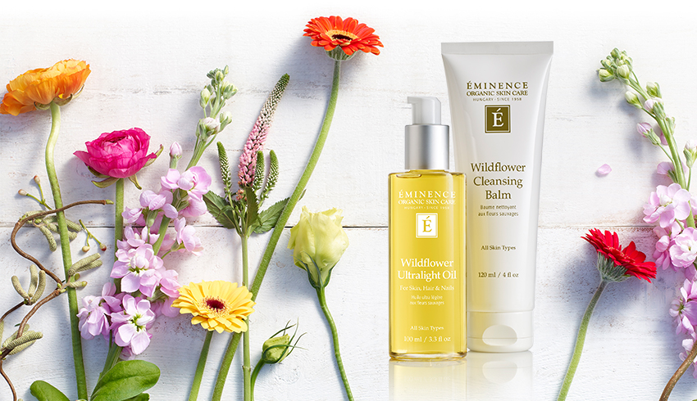

Get your skin blooming with Eminence’s new Wildflower collection!
If your skin needs some extra TLC recovering from winter damage, then these products are great for you. The Wildflower Collection is anti-inflammatory and is great for all skin types (even oily!).

Eminence’s Wildflower Cleansing Balm is the lighter cousin of the Stone Cleansing Oil. One of its key ingredients is elderflower. Elderflower is great for smoothing wrinkles and reducing pore size. The balm also contains poppy seed oil to rehydrate the skin, and- at the same time, remove excess oil. This product works well with or without water and leaves the skin feeling soft and fresh.

The Wildflower Ultralight Oil is a multipurpose, lightweight oil meant for the face, body, hair and nails. Unlike like coconut oil, this product seeps into your skin to give you better hydration. The evening primrose helps generate hair, nail and skin cells as well as keep away hormonal acne. It also contains Echinacea oil to fight off bacteria that causes infections and dandruff.

Both products are high in linden flower, which eases inflammation while preventing impurities. Eminence’s Wildflower Collection also pairs well with Eminence’s Stonecrop line (a travel sized Stonecrop masque is gifted to you when you purchase both Wildflower products). Come in and try our Wildflower Summer Facial and see if these products are great for you!

